* The URLs for each page:

Home: <https://talhawan.github.io/talhas-organization/>

About: <https://talhawan.github.io/talhas-organization/about.html>

Contact Us: <https://talhawan.github.io/talhas-organization/contact.html>

Services: <https://talhawan.github.io/talhas-organization/services.html>

Gallery: <https://talhawan.github.io/talhas-organization/gallery.html>

* I used Chrome and Firefox to test.
* Pasted image from your validation screen capture.

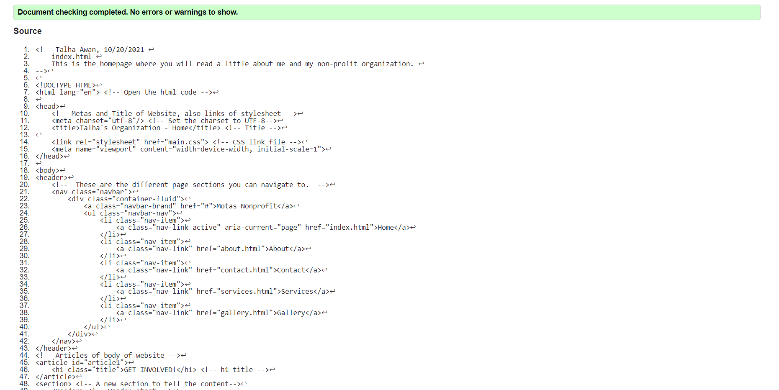

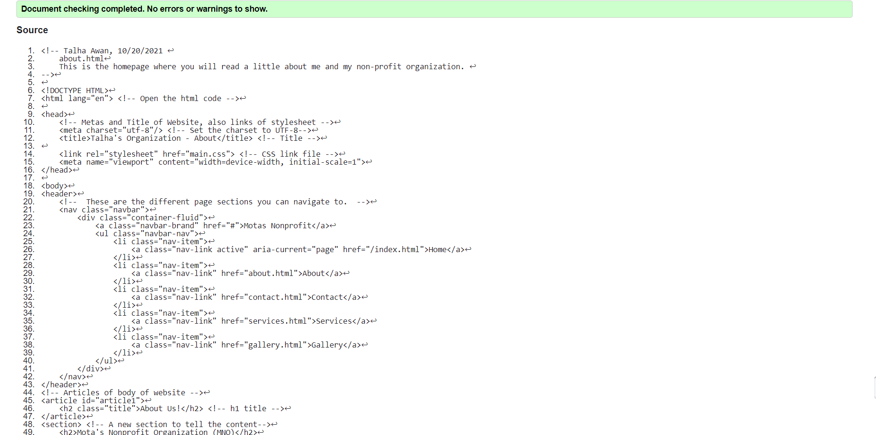

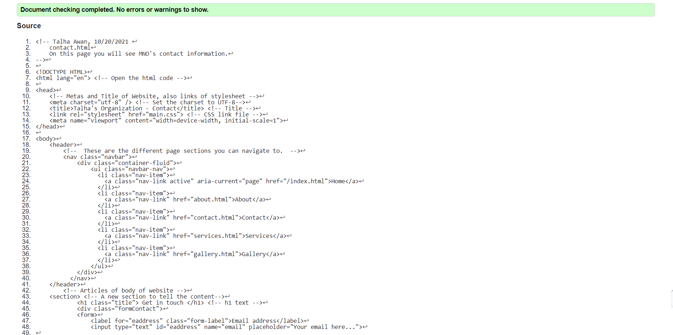

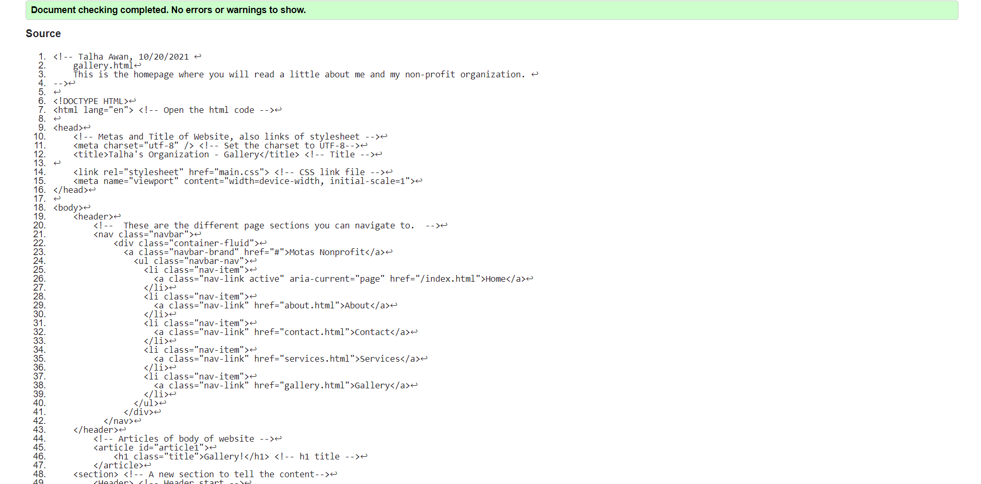

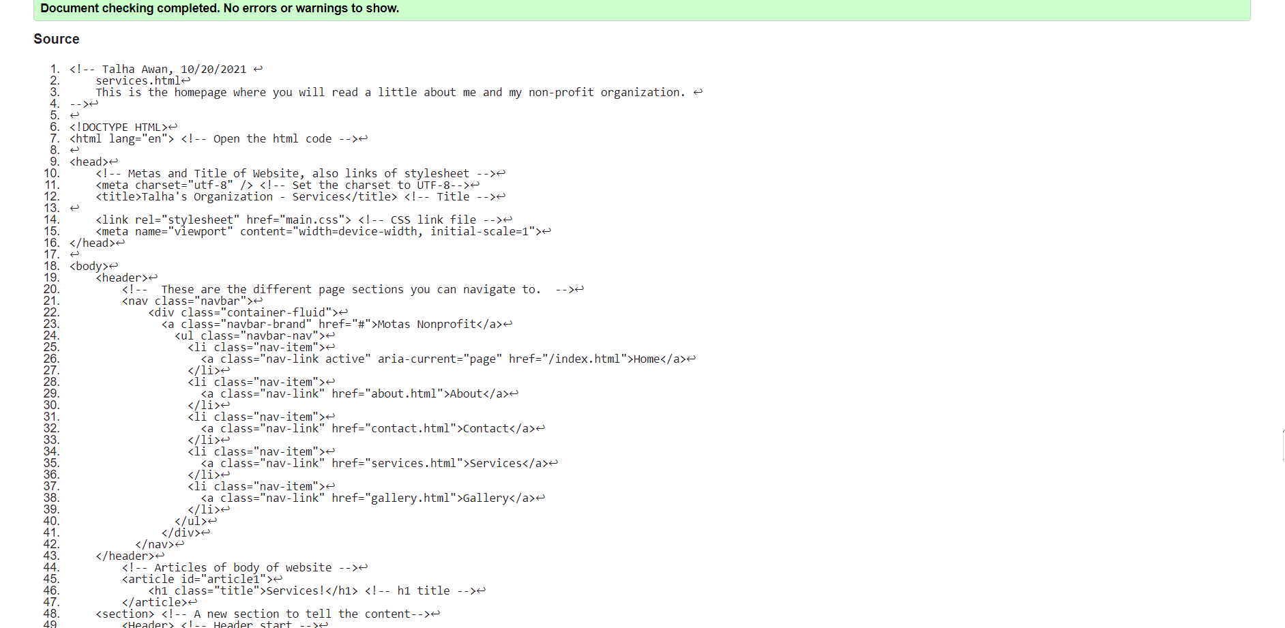

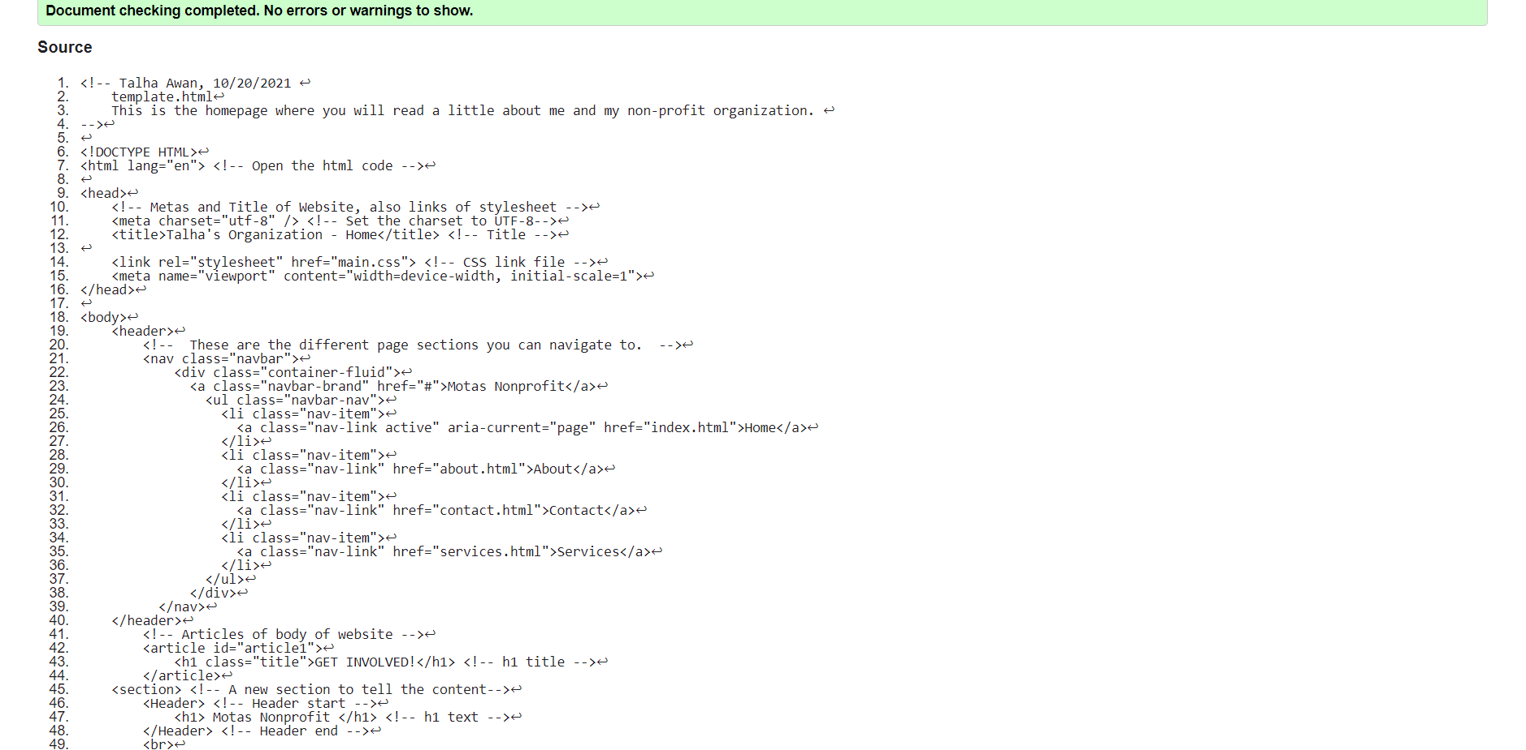

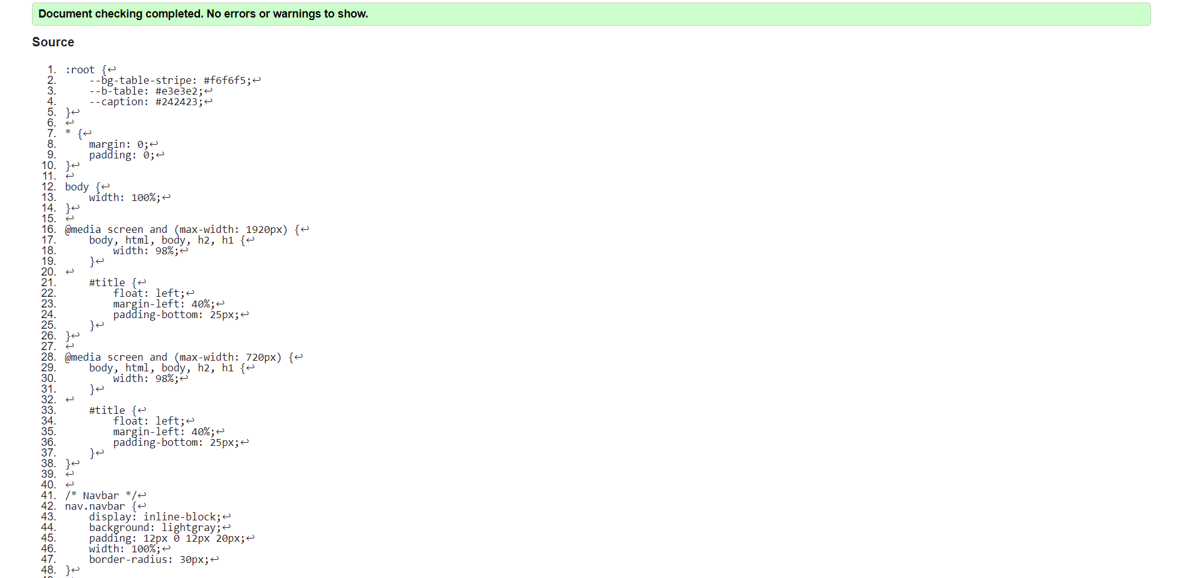

Any ancillary files such as graphic or photos you may have decided to include.



